

Practices for Secure Software Report

Table of Contents
Document Revision History 3
Client 3
Instructions 3
Developer 4
1. Algorithm Cipher 4
2. Certificate Generation 4
3. Deploy Cipher 4
4. Secure Communications 4
5. Secondary Testing 4
6. Functional Testing 4
7. Summary 4
8. Industry Standard Best Practices 4

Document Revision History

Version | Date | Author | Comments
1.0 | 4/27/25 | Justin Whooley

Client



Instructions

Submit this completed practices for secure software report. Replace the bracketed text with the relevant information. You must document your process for writing secure communications and refactoring code that complies with software security testing protocols.

- Respond to the steps outlined below and include your findings.
- Respond using your own words. You may also choose to include images or supporting materials. If you include them, make certain to insert them in all the relevant locations in the document.
- Refer to the Project Two Guidelines and Rubric for more detailed instructions about each section of the template.

Developer
Justin Whooley

Algorithm Cipher

The cipher suite I would recommend is TLS_ECDHE_EDSA_WITH_AES_128_CBC_SHA, specifically the cipher algorithm being recommended is the AES_128_CBC (Advanced Encryption Standard, 128-bit, Cipher Block Chaining). AES is a symmetric encryption algorithm utilizing 128-bit keys to encrypt and decrypt data in CBC mode. The rest of the cipher suite indicates the use of the TLS protocol for secure transmission, ECDHE and ECDSA serve as the key exchange mechanism and the server side authentication, the SHA hash function is used for data integrity to ensure that the data has not been manipulated in any way. Random numbers are used for generating keys in order to improve security through uniqueness and unpredictability. AES utilizes symmetric keys to encrypt and decrypt the actual data being transmitted, while non-symmetric keys are utilized during key exchange and key authentication. Ciphers date back thousands of years one of the earliest going back to the ancient Greeks. The original purpose of these ciphers were to keep military communications secure. As the years have gone on and technology has progressed the idea of the cipher was adapted to different scenarios. One advancement is morse code use to communicate over distance using electrical signaling a cipher was created to convert messages into a series of beeps and pulses which is then decoded by the person receiving the message on the other end. Now we computers to do everything in our daily lives which leads to inevitably revealing private information, to keep this information private ciphers are necessary.

Certificate Generation
Insert a screenshot below of the CER file.

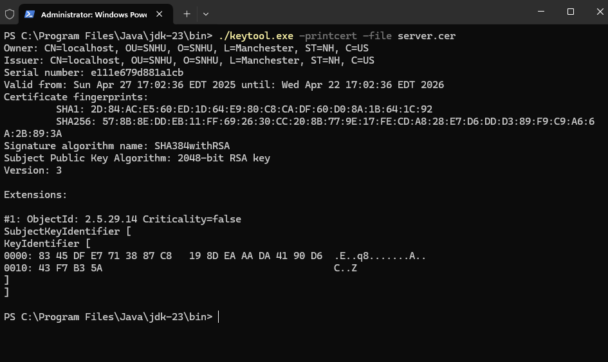

Deploy Cipher
Insert a screenshot below of the checksum verification.

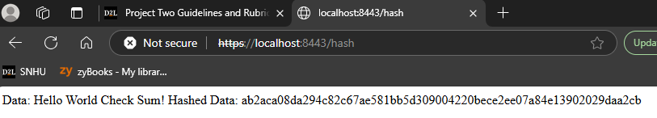

Secure Communications
Insert a screenshot below of the web browser that shows a secure webpage.

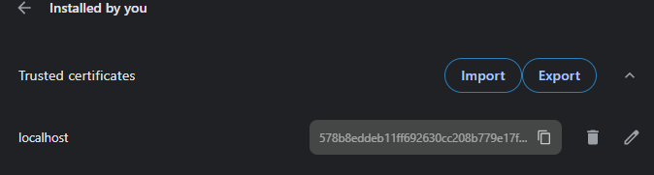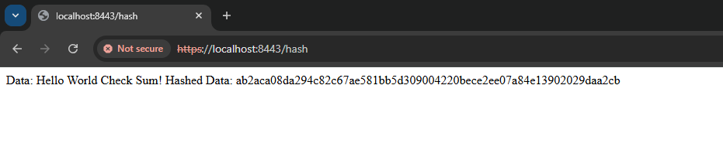
As you can see you can connect via HTTPs currently but because the certificate is selfsigned there is some secure connection issues that will be resolved once a proper CA is set up on a server.

Secondary Testing
Insert screenshots below of the refactored code executed without errors and the dependency-check report.

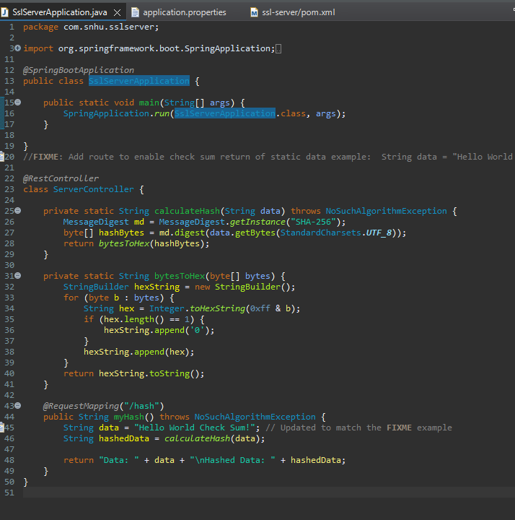
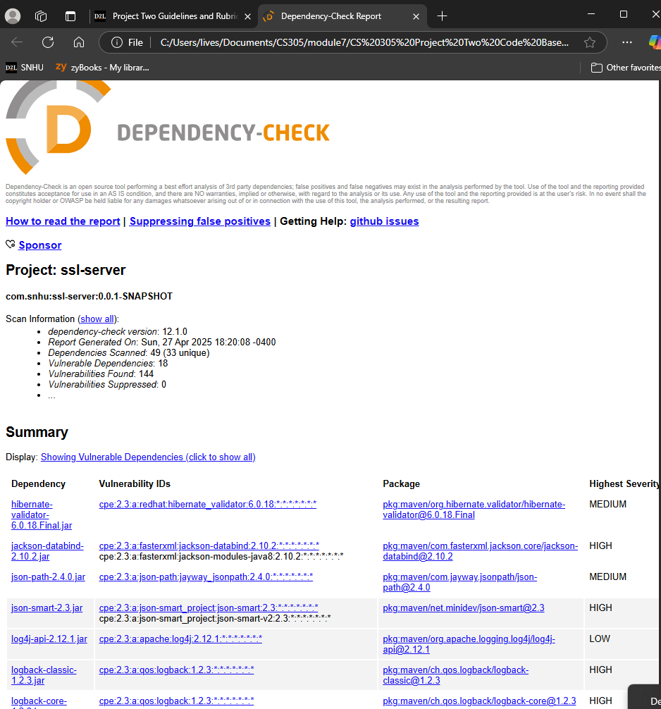

Functional Testing
Insert a screenshot below of the refactored code executed without errors.

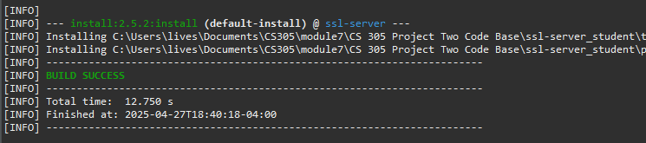

Summary

In refactoring we added data integrity through a checksum verification. A proper cryptographic cipher algorithm was deployed to ensure proper authentication and authorization. Also establishing https enforcement will add another layer of security.

Industry Standard Best Practices

AES_128 meets industry standards as well as meets PC-DSS compliance requirements. Meeting industry standards and following best practices while writing code ensures quality safety and efficiency while building projects that will be trusted by many end users.

